

NOVAC TECHNOLOGY SOLUTIONS

User Manual

Document Version No.: 1.00

Revision History
Version No | Reason For Changes | Author | Approver
0.01 | Draft | Anurag Kumar
1.00 | Reviewed & Approved the User Manual | Anurag Kumar | NIJANTHAN PL

Table of Contents
1. Introduction 4

2. Changes in the Policy Receipt Screen 4

Introduction

The purpose of this requirement is to include all existing receipt details for the corresponding policy in the Policy Receipt screen.

- Guidelines, circulars, instructions and directions released from time to time by Philippines Insurance council.

Changes in the Policy Receipt Screen

- In the current Policy receipt screen, there is no provision to see the existing receipt details for the corresponding policy.
- Now system is required to auto default the existing receipts details for the corresponding policy in the Policy receipt screen if policy have the receipts when clicking the “Go” Button.

Policy Receipt Screen – S0506

- Search the Policy Receipt Screen
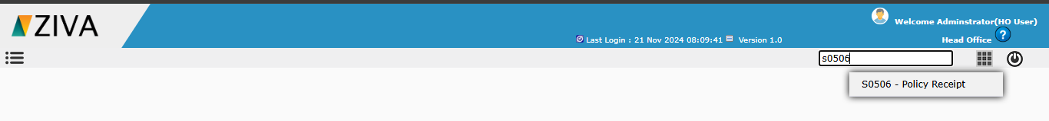

- Click on the screen menu and it will redirect the Policy Receipt screen and enter the mandatory details and click on GO button.

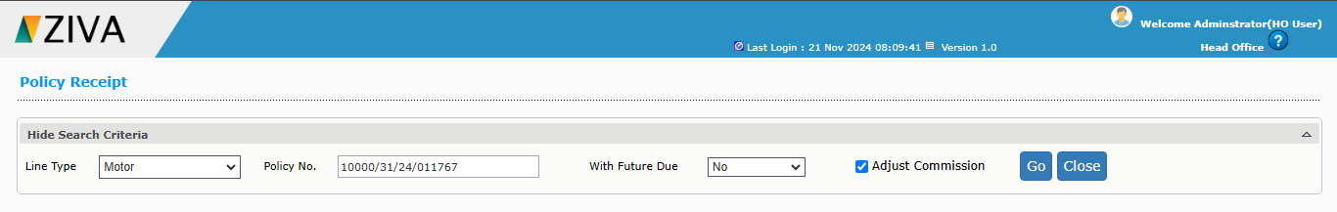

- System will display the history of payment made against the policy.

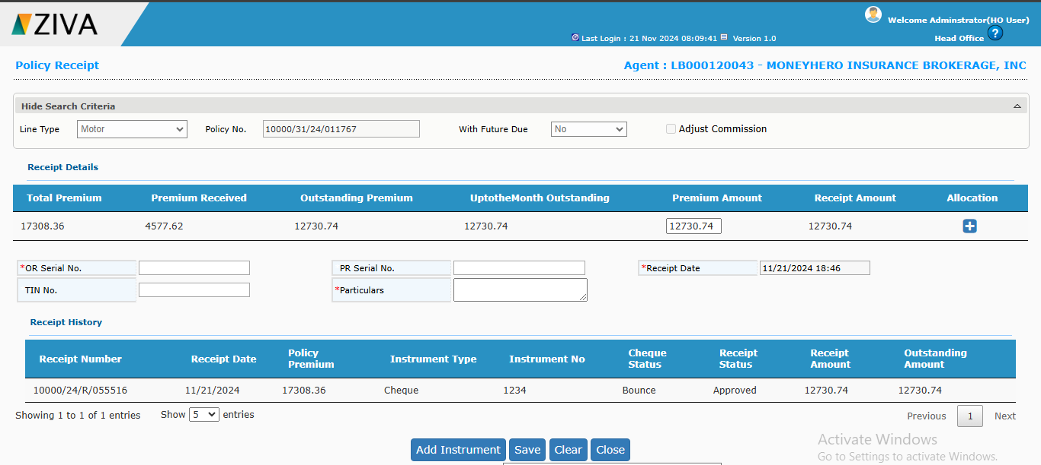

Click on close button to close the window.

